TMS Web Nominations
User Manual

Contents
Click the red page number to the right of the paragraph heading to navigate to that section.
Icons and Conventions Used in this Manual 5
Assumptions 6
Introduction 7
Screen Layout 7
DRN and Point Number Mode 7
TMS Overview 8
Nomination Services 8
Pathed Nomination 9
Nonpathed Nomination 9
TMS System 10
Nomination 11
Open/Copy Nomination Screen 11
Open an Existing Nomination 11
Copy a Contract’s Nominations for a Specified Date 13
Open/Copy Nomination Screen Field Help 15
Nomination Maintenance Screen 16
Create a New Nomination Using the Add Button 16
Replace an Existing Nomination Using the Change Button 21
Pool Nominations 23
Nomination Maintenance Screen Drop-Down Menus 26
Nomination Maintenance Screen Field Help 29
Nomination Reconciliation Screen 31
Nomination Reconciliation Screen Field Help 33
EDI Nom Quick Response View Screen 35
EDI Nom Quick Response Screen Field Help 36
Scheduling 38
Scheduled Quantities 39
Scheduled Quantities Screen Field Help 43
Scheduled Quantity by Contract 45
Scheduled Quantity By Contract Screen Field Help 46
Contract Quantity Detail Screen Field Help 48
Scheduled Quantities by Contract and Location 49
Scheduled Quantities by Contract and Location Screen Field Help 51
Scheduled Quantities by Contract, By Location and Up/Down Contract 52
Batch Schedule Status 54
Reporting 55
Scheduled Quantities Reports 55
Service Requester Report 57
TMS Generic Screen Functions 61
System Tool Bar Icons 61
Search Facility Option 63
Search and Location Search Options 63
Receipt/Delivery Locations Valid for Contract 67
Location Detail Information Display 68
Sort 69
Data Sorts 69
Column Sorts 71
Print 71
Export 72
Cancel 73

Icons and Conventions
Used in this Manual

NOTE: A note is used to draw your special attention.

GOOD IDEA: A good idea is a strong recommendation.

 REMEMBER: A reminder.

Menu Names: | Menu names display like this.
Field Names: | Field names display in Italics.
Screen Names: | Screen titles display like this.
Dialog Box Names: | Dialog Box titles display like this.
Select Multiple Options: | Select File|New from the main menu.
Drop-down box arrow: | Click on arrow and selection list displays.
Buttons: | Buttons are displayed graphically.

Assumptions
It is assumed that you already have the proper security set up for your ID to perform the operations described in this manual.
It is assumed that you know how to access the Throughput Management System (TMS).
The new TMS Web screens are set to use the NAESB EDM Standards defined for your desktop resolution. The standard suggested is 1024 X 768 setting which will allow you to view TMS Web as designed. Please adjust your setting accordingly.

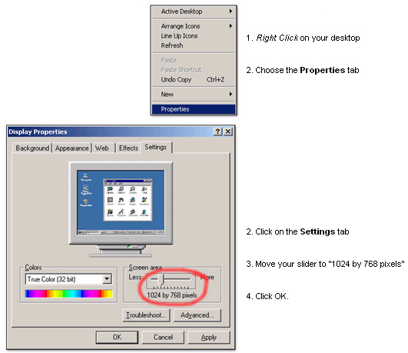

Introduction

Screen Layout
All screens in the TMS system have the same basic layout: the Form area where you enter data and the Matrix area where you view data. The column headings at the top of the Matrix area reflect the field titles in the Form area (Figure 1).
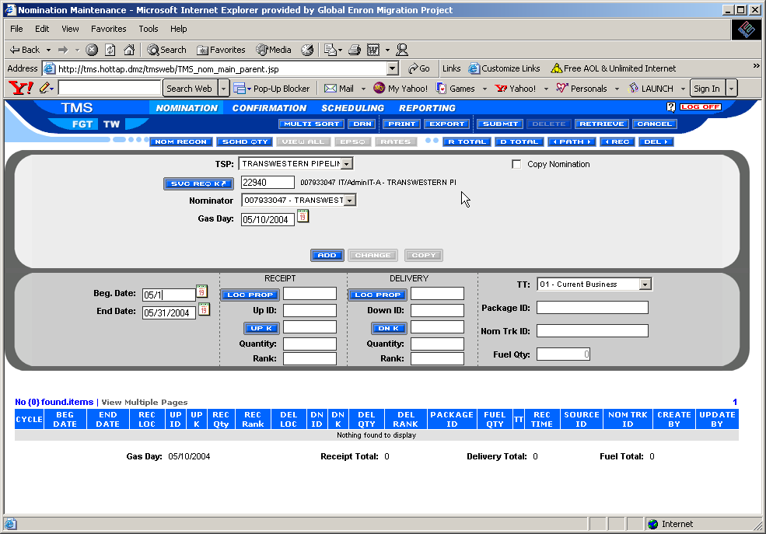
Figure 1. Nom Screen Layout

DRN and Point Number Mode
Nomination Maintenance operations differ slightly among pipelines. By default FGT displays the Data Reference Number (DRN) location. The DRN is the NAESB-defined method for identifying location. As shown in Figure 3 and 4, the button title changes depending upon which mode you select.
Figure 3. Point Number Mode Figure 4. DRN Mode

TMS Overview

Nomination Services
The TMS system is the medium customers use to request specific pipeline services.
Following are the service types provided by the Nomination system:
- Firm Transportation | Transportation from primary receipt points to primary delivery points under a rate schedule that is performed on a firm basis.
- Interruptible Transportation | Gas transported under this rate schedule is on an interruptible basis when capacity exists on the Transporter’s system.
- Pooling | This service allows for the aggregation of receipts to logical point(s) that can be transported from the logical point(s) to multiple delivery points.
- Park N Ride (P-N-R) | This service provides flexibility to Service Requesters whose gas supplies are either long (Park) or short (Ride) on an interruptible basis.
In order to request one of the service types, you must first execute a contract with the respective pipeline. Currently, each service type requires a separate contract to be in place. You may have several valid contracts in place simultaneously, with each contract authorizing a different service type. A contract identifies the customer, effective dates, valid receipt and delivery points, valid alternate receipt and delivery points, and maximum daily quantities available at the point and contract level along with specific rates associated with the contract.
Once the contract is in place, you can then make any number of nominations to this contract. A nomination is a specific request for service that is tied to one and only one contract. It specifies the date range for which the service is being requested, receipt and delivery points, quantities to be transported, path priorities, third-party upstream and downstream entity, quantity, and ranking. In other words, a nomination clearly identifies the amount of gas a service requester expects to transport on the pipeline subject to the terms and conditions of the contract under which the service is being requested.
TMS uses the following nomination model types to enable current business practices of each pipeline:
- Pathed
- Nonpathed
Each nomination model type varies by its structure and type of data required for identifying the specifics of the service being nominated.

Pathed Nomination
Pathed nomination describes the transportation of a specific quantity of gas from one receipt point to a delivery point. The nomination also identifies the upstream and downstream contracts and/or parties, ranking, and receipt/delivery point priorities on a path. Based on the path being nominated and tariff fuel rates, the system calculates the fuel needed to transport the gas. The delivery quantity always equals the receipt quantity less fuel.

Nonpathed Nomination
The nonpathed nomination is a transaction at a receipt location or a delivery location. The nomination line item depicts a single request for a receipt or delivery quantity of gas for a specific location and date. The one-sided nonpathed nomination is used to request makeup, or Park-N-Ride transactions. There is no direct correlation between receipts and deliveries of gas.
The nonpathed model is also used to aggregate receipt quantities to a specific pool location and may be used in some pipelines to disaggregate from a pool location to multiple markets. FGT allows service requesters to use the pathed or unpathed nomination model for pooling.

TMS System
The TMS system is used to perform the following tasks:
- Enter and view nominations
- Enter and view operator confirmations
- View operator and service requester scheduled quantities
The TMS Operator confirmation manual covers Confirmation, Scheduling, and Reporting.
This TMS Nomination User manual covers only the menu options and screen functions shown below.
- Nomination (Page 13)
- Scheduling (Page 48)
- Reporting (Page 70)
- TMS Generic Screen Functions (Page 78)
The TMS Nominations and Scheduling system is comprised of a series of menus and screens that aid you in submitting your nominations. You access the system via the TMS Main Menu.
Figure 5. TMS Main Menu

Nomination
This section explains how to use the various nomination screens to enter nominations based on the pathed NAESB model. Following are the screens documented:
- Open/Copy Nomination Screen (Page 13)
- Nomination Maintenance Screen (Page 19)
- Nomination Reconciliation Screen (Page 39)
- EDI Nom Quick Response View Screen (Page 44)

Open/Copy Nomination Screen
The purpose of the Open/Copy Nomination screen is twofold:
- To open an existing nomination or begin a new nomination for a specific contract (Page 13)
- To copy a contract’s nomination(s) for a specified date (Page 15)

Open an Existing Nomination
To open an existing nomination(s) or begin a new nomination for a particular gas date, you must specify the contract to which this nomination belongs. You can then view, change, update, or add a new nomination for that contract. The instructions below explain how to open a contract and access an existing nomination for a particular gas date.
1. Select Nomination|Nomination Maintenance on the Hot Tap Main Menu (Figure 2).
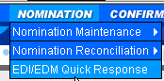
Figure 2. Nomination Drop-Down Menu
The Nomination Maintenance screen opens (Figure 3). To enter the service requester contract number, you will gain access to the Nomination Maintenance screen via the Open/Copy Nomination screen (Figure 3). You will gain access to the Nomination Maintenance screen via the Open/Copy Nomination screen.
See the Open/Copy Nomination Screen Field Help section on Page 17 for a definition of each of the field names.
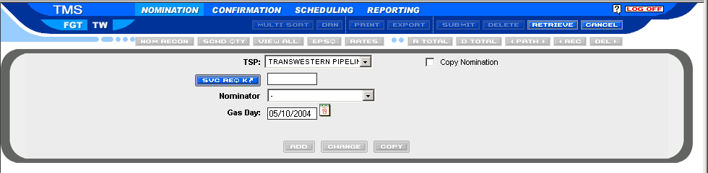
Figure 3. Open/Copy Nomination Screen
- Click the down arrow in the TSP field and select Florida Gas Transmission Company (Figure 3).
- Tab to the Svc Req K field and type the appropriate contract number, or
right-mouse-click in the Svc Req K field to invoke the contract search function.
(See the Search Facility Option section on Page 81 for instructions on performing a search).
The Nominator field populates with related data based on the contract number you entered in the Svc Req K field. For FGT, click on the nominator field and select the correct nominator designee.
- Tab to the Gas Date field and type the start date of the nomination(s) you want to open. Use the mmddyy format. Click the backward or forward arrow to change gas date to previous or next gas day, or select gas day by using the calendar.
- Click Retrieve.
The Nomination Maintenance screen opens. It is populated with any preexisting nominations for the contract and gas date you selected (Figure 4).
You are now ready to enter your nomination.
See the Nomination Maintenance Screen Field Help section on Page 36 for a definition of each of the column headings.
NOTE: If desired, click to close the Nomination screen and return to the Nomination Maintenance screen.
Click on the green “open new” box to open a new contract for a new gas date under your current user ID logon. This will allow you to open up to three separate nomination quantities screens at one time.
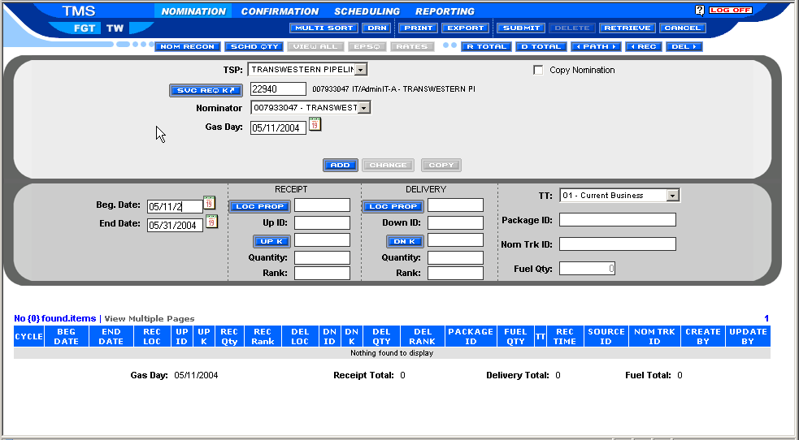
Figure 4. Nomination Maintenance Screen
NOTE: As shown in Figure 4, screens are organized into two main areas: the Form Area where you enter data and the Matrix Area where you view data.

Copy a Contract’s Nominations for a Specified Date
The purpose of the copy function is to save you time when entering new nominations for a particular contract. Rather than having to re-key data that will remain constant over the course of the contract, you can copy a contract’s nominations for a specified date range. The instructions below explain how to copy a contract’s nominations for a specified date. This copy feature works for all nomination contract types, such as pooling, storage, transportation, and P-N-R. The copy process will copy only paths with valid upstream and downstream contract numbers on the pipeline.
NOTE: If the upstream or downstream contracts are no longer valid, you must update using valid contracts prior to saving. See the Create a New Nomination Using the Add Button section beginning on Page16.
1. Select Nomination|Nomination Maintenance on the TMS Main Menu (Figure 2).
The Nomination Maintenance screen (Figure 4) opens. You will gain access to the Nomination Maintenance screen via the Open/Copy Nomination screen.
See the Open/Copy Nomination Screen Field Help section on Page 17 for a definition of each of the field names.
- Click the down arrow in the TSP field and select Florida Gas Transmission Company.
- Tab to the Svc Req K field and type the appropriate Contract Number, or click in the Svc Req K field to invoke the contract search function. (See the Search Facility Option section on Page 81 for instructions on how to perform a search).
- Click the box to the left of Copy Nomination so that a check mark appears there.
- Type the date of the specific nomination(s) that you want to copy in the From Date field and press the Tab key.
- Type the start and end date that you want to copy the nomination to in the To Start and End fields and Tab.
- Click Copy.
The Nomination Maintenance screen opens. The newly copied nomination line item(s), any line items containing the new date(s) you specified, and any line items existing for the remaining days of the month populate the Matrix area of the screen (Figure 4).
See the Nomination Maintenance Screen Field Help section on Page 36 for a definition of each of the column headings.
NOTE: Once the current gas day processes have started, you cannot copy that day’s nomination.
- Click Submit to save the new nomination.
The Update Successful dialog box appears to notify you that the Nomination copy you made has been saved to the system.

Open/Copy Nomination Screen Field Help
Field Name | Definition
TSP (Transportation Service Provider) | Transportation Service Provider. Name of the pipeline: Florida Gas Transmission Company.
Svc Req K | Service Requester Contract number. The service requester transportation number assigned to a particular contract.
Copy Nomination | A check box that enables you to specify that you want to make a copy of an existing nomination.
End | The date you want the nomination copy to end.
From Date | The specific date of the nomination that you want to copy.
Gas Date | The start date of the nomination.
Nominator | The DUNS number assigned to the service requester nominating gas on the pipeline.
To Start | The date you want the nomination copy to start.
 | Cancels the data you entered on the Open/Copy Nomination screen and closes it.
 | Accepts the data you entered on the Open/Copy Nomination screen and closes it. This data now populates the Nomination Maintenance screen.

Nomination Maintenance Screen
After either opening or copying a contract’s nomination(s), you are now ready to navigate the Nomination Maintenance screen where you can perform the following tasks.
- Create a new nomination using the Add button.
- Replace an existing nomination using the Change button.
See the Nomination Maintenance Screen Field Help section on Page 36 for a definition of each of the column headings.

Create a New Nomination Using the Add Button
Three nomination scenarios exist.
- Pathed | Both a receipt and a delivery location.
- Receipt | One-sided nonpathed. There is no delivery location.
- Delivery | One-sided nonpathed. There is no receipt location.
Pathed
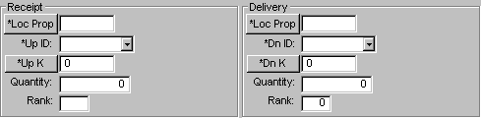
Receipt  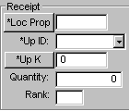 |  | Delivery  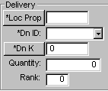
Figure 5. Nomination Types (Pathed, Receipt, and Delivery)
You can create a new nomination for the following scenarios:
- Create a New Nomination by Entering New Data in All the Nomination Data Fields (Page 20).
- Create a New Nomination by Using an Existing Nomination as a Template (Page 27).

Create a New Nomination by Entering New Data in All the Nomination Data Fields
- Select Nomination|Nomination Maintenance on the TMS Main Menu.
- The Nomination Maintenance screen appears.
- Click the down arrow in the TSP field and select Florida Gas Transmission Company.
- Tab to the Svc Req K field and type the appropriate Contract Number for the new nomination that you want to create.
- Click Retrieve.
The Nomination Maintenance screen Matrix area populates with any
pre-existing nominations for the contract and gas date you selected.
- Ensure that no nomination path is selected or highlighted in the Matrix area of the Nomination Maintenance screen. If one is selected, click on it to deselect it.
- Type the desired start and end dates in the *Beg and *End fields and Tab (Figure 4).
NOTE: The *Beg field defaults to the start date entered on the Open/Copy Nomination screen. The *End field defaults to the end of that month. The *TT field populates based on the contract that was invoked. All other fields are either blank or contain a zero.
- Click the desired nomination type icon: , , or .
The appropriate fields for the nomination type selected display.
- Enter the appropriate data for the nomination type you selected and Tab.
The instructions below explain how to populate each field (starting with the Receipt fields and Tab through the data fields).
See the Nomination Maintenance Screen Field Help section on Page 36 for field definitions.
Receipt Data Input Fields
- Type the receipt location in the Receipt *Loc Prop field or click in the *Loc Prop field to invoke the Search function.
NOTE: If you are relying on the search function, in this instance you will see Receipt Locations Valid for Contract menu item. This will narrow your search considerably by taking you directly to a list of receipt locations that are valid for the selected contract only.
See the Search Facility Option section on Page 81 for detailed instructions on performing a search.
- Press the Tab key.
The cursor jumps to the Receipt *Up K field.
- Type the upstream contract number in the Receipt *Up K field and press the Tab key.
The cursor jumps to the Receipt *Up ID field.
- Click the down arrow in the Receipt *Up ID field and select the appropriate DUNS Number for the upstream contract.
- Press the Tab key.
The cursor jumps to the Receipt Quantity field.
- Type the receipt quantity in the Receipt Quantity field and press the Tab key.
The cursor jumps to the Receipt Rank field.
NOTE: Leave the Receipt Quantity field blank if you want the fuel and receipt quantity calculated based on the delivery quantity.
- Type the receipt rank in the Receipt Rank field and Tab.
NOTE: If you leave the Receipt Rank field blank, the system will automatically assign a rank of 500.
- Click if you are creating a one-sided nonpathed receipt transaction.
If you are creating a full pathed transaction, do not click , continue with the Delivery Data Input Fields steps shown below.
The new nomination is added to the Matrix area if it passes the system validation edits, such as duplicate paths, valid locations, and valid dates.
Delivery Data Input Fields
- Type the delivery location in the Delivery *Loc Prop field or right-click in the *Loc Prop field to invoke the Search function.
See the Search Facility Option section on Page 81 for instructions on performing a search.
NOTE: If you are relying on the search function, in this instance you will want to select Delivery Locations Valid for Contract menu item. This will narrow your search considerably by taking you directly to a list of delivery locations that are valid for the selected contract only.
See the Search Facility Option section on Page 81 for detailed instructions on performing a search.
- Press the Tab key.
The cursor jumps to the Delivery *Dn K field.
- Type the downstream contract number in the Delivery *Dn K field and press the Tab key.
The cursor jumps to the Delivery *Dn ID field.
- Click the down arrow in the *Dn ID field and select the appropriate DUNS number for the downstream contract and press the Tab key.
The cursor jumps to the Delivery Quantity field.
- Type the delivery quantity in the Delivery Quantity field and press the Tab key.
The cursor jumps to the Delivery Rank field.
NOTE: Leave the Delivery Quantity field blank if you want it calculated on the receipt quantity less fuel.
- Type the delivery rank in the Delivery Rank field and Tab.
NOTE: If you leave the Delivery Rank field blank, the system will automatically assign a rank of 500.
- Type the package ID in the *Package ID field if applicable to your business requirements and Tab. This is a service requester-optional field.
NOTE: The system assigns a default transaction type based on the contract type and the nomination type.
If needed, you can change the transaction type. To accomplish this, click the down arrow in the TT field and select the type that is appropriate for your nomination.
- Click .
The new nomination is added to the Matrix area if it passes the system validation edits, such as duplicate paths, valid locations, and valid dates.
NOTE: When you use the Add button, the system checks for duplicates for the date range you entered. It compares the new nomination with the existing nominations. If a duplicate nomination exists, an error message displays.
If you use the Add button to add new nominations prior to the Nomination Cycle deadline and then save after the deadline, the system displays an error message stating that the deadline has passed. You must re-retrieve the data and make changes again for the next nomination timeline cycle.
- Click Submit to save the new nomination.
A dialog box appears to notify you that the update was successful.
See the Nomination Maintenance Screen Field Help section beginning on Page 36 for a detailed description of each field.

Create a New Nomination by Using an Existing Nomination as a Template
To save time, you can use an existing nomination as a template for creating a new nomination. Once you have existing nomination data, you can modify it as needed for your new nomination. The existing nomination that you used as a template is not changed. The instructions below explain how to accomplish this task.
- Click on the nomination line item in the Matrix area that you want to use as a template to highlight it.
The data from that nomination populates the Form area.
- Change the data in any of the fields as needed and press the Tab key to activate the change.
NOTE: The begin date of the new nomination you are creating from the template must be the current gas day or a later date.
The system will not create a new nomination if the begin date is earlier than the current date.
If the begin date is the same as the current gas date or equal to the upcoming gas date, and the deadline time has passed for the upcoming gas date, you must make the new nomination effective for one date only.
- Click after you have changed all the desired fields.
The new nomination is added to the data display area if it passes the system validation edits, such as duplicate paths, valid locations, and valid dates.
- Click Submit to save the new nomination.
A dialog box appears to notify you that the update was successful.

Replace an Existing Nomination Using the Change Button
The purpose of the button is to allow you to replace a nomination line item for a specific date range with a new nomination once gas has been scheduled for that day. The system may split the existing nomination into different date ranges depending on the start and end dates of the original nomination when compared with the date ranges of the new nomination. The new nomination’s start/end date must fall within the original dates.
Following are instructions for replacing a nomination.
For detailed field information see the Nomination Maintenance Screen Field Help section on page 36.
- Click once on the existing nomination line item that you want to replace.
The data from that nomination appears in the data entry area.
- Update any data field item including dates, locations, quantities, receipt and delivery contracts, ID codes, transaction types, ranks, or package Ids and press the Tab key to activate the change.
- Click to update that existing nomination with these changes in the data display area.
NOTE: The system checks for duplicate lines and displays an error message if a nomination already exists for the new date range.
If no duplicate exists, the system inserts the new nomination within the original nomination’s start and end dates and splits the original nomination if necessary.
If you use the button to update a nomination prior to the nomination deadline and save after the deadline, the system will display an error message stating that the deadline has passed. You must then re-retrieve the data and make changes again for the next nomination cycle.
If you use the button after the timely deadline, and the original nomination has already been scheduled, the system inserts (replaces) the new nomination within the original nomination. The system splits the original nomination, if necessary, and creates an Intraday nomination from the original nomination. The original nomination is given a quantity of zero or its EPSQ value.
- Click Submit to save the new nomination.
A dialog box appears to notify you that the update was successful.

Pool Nominations
Pool nominations consist of three types of transactions:
- Nonpathed one-sided receipt transactions (Page 29)
- Nonpathed one-sided delivery transactions (Page 32)
- Pathed for FGT (See Create a New Nomination… on Page 20)
A pooling nomination serves as an aggregation function whereby the service requester can nominate many receipts in an area into a logical pooling location in the same area. No gas is transported.
Following are the instructions for entering the supply pool nominations.

Receipt Transactions
1. Select Nomination|Nomination Maintenance on the Hot Tap Main Menu.
The Nomination Maintenance screen appears and is overlaid by the Open/Copy Nomination screen. You will gain access to the Nomination Maintenance screen via the Open/Copy Nomination screen.
NOTE: If you already have the Nomination Maintenance screen open, click the Open icon (Alt+O) to invoke the Open/Copy Nomination screen.
- Click the down arrow in the TSP field and select Florida Gas Transmission Company.
Tab to the Svc Req K field and type the appropriate FGT Pool Contract Number, or Right-mouse-click in the Svc Req K field to invoke the contract search function. See the Search Facility Option section on Page 81 for instructions on how to perform a search.
- Tab the Gas Date field and type the appropriate date you want the nomination to start.
NOTE: The Pool field appears as you Tab onto the Gas Date field. This only happens when you are in a pooling nomination.
- Click the drop-down arrow in the Pool field and select the appropriate pool.
- Click Retrieve.
The Nomination Maintenance screen populates with the pre-existing nominations for the contract and gas date you selected (Figure 6).
NOTE: FGT pool nominations can be entered by using the pathed or nonpathed model types. For convenience, FGT allows you to enter and save out of balance nominations. You can also copy a pooling nomination to a new date range like you can copy a path nomination.
See Copy a Contract’s Nominations for a Specified Date on Page 15.

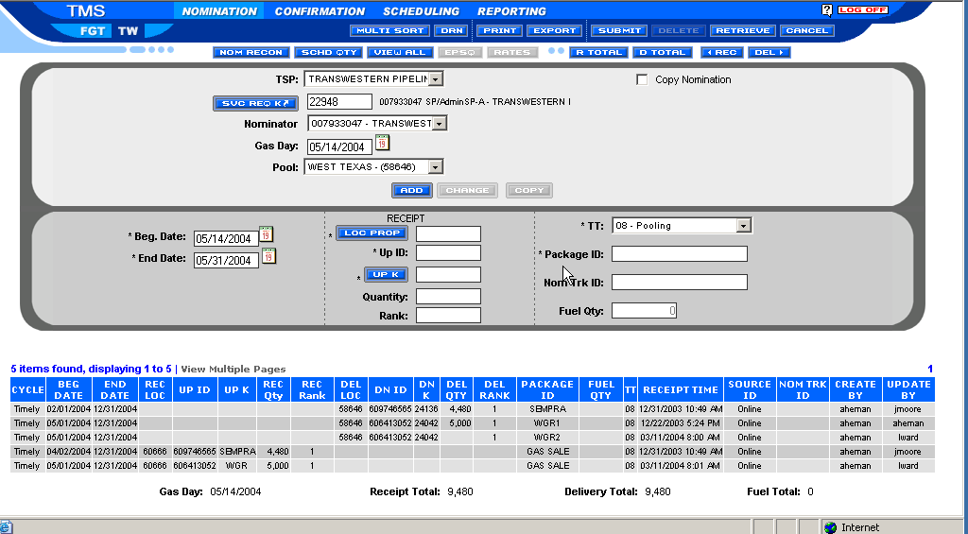
Figure 6. Nomination Maintenance Screen⎯Pool Nominations
- If desired, you can select a different pool than the one you selected on the dropdown pool list on the nomination screen.
To accomplish this, click the down arrow in the Pool field on the Nomination Maintenance screen and select appropriately.
The system will default to the receipt side data fields.
- Type the date range in the Receipt Beg/End date fields and Tab.
Beg—date you want the gas to start flowing.
End—date you want the gas to stop flowing.
- Type the valid location number for that pool in the Receipt *Loc Prop field and Tab.
- Type the receipt upstream contract number in the Receipt *Up K field and Tab.
- Type the ID code in the Up ID field or click the down arrow and make a selection and Tab.
- Type the quantity of gas (DTH) you want to nominate in the Receipt Quantity field and Tab.
- Type the rank in the Receipt Rank field and Tab.
- Type the Package ID in the Package ID field if needed and Tab. This is an optional field.
- Click either or after each nomination.
See Create a New Nomination Using the Add Button on Page 19 and Replace an Existing Nomination Using the Change Button on Page 27.
NOTE: Transaction Type for Pools will default to Pooling 08.
- Repeat Steps 7 through 14 above to add additional receipt quantities and receipt paths for the selected pool.
- Click Submit to save the new nomination.
A dialog box appears to notify you that the update was successful.

Delivery Transactions
- Click the icon in the menu bar to enter deliveries.
- The pool delivery location for the associated pool in the Delivery Location field will default.
- Type the pool delivery downstream contract in the Delivery *Dn K field and Tab
- Type the pool ID code in the Down ID field and Tab.
- Type the pool quantity in the Delivery Quantity field and Tab.
- Type the pool rank in the Delivery Rank field and Tab.
- Click or after each nomination.
The Location field associated with the pool automatically populates when you select the pool.
- Steps 2 through 7 may be repeated for other pools.
- Click Submit to save the new nomination.
A dialog box appears to notify you that the update was successful.

Other Nonpathed One-sided Transactions ( Makeup, Park-N-Ride)
Other one-sided nominations consist of the following:
- Makeup
- Park-N-Ride
The nonpathed nomination transactions are used to enter either receipts or deliveries associated to these one-sided transactions.

Nomination Maintenance Screen Drop-Down Menus
The Nomination Maintenance screen provides a menu bar from which you can select options to aid you in navigating the system. This menu bar is generic to all screens throughout the system (Figure 7).
See the System Tool Bar Icons section on Page 78 for a detailed description of each of the icons on the menu bar.
Figure 7. Nomination Maintenance Screen Tool Bar
Screen Menu Items

For more information see the DRN and Point Number Mode section on Page 7.
Options⎯Display Names | Options⎯Display Numbers by Loc Prop or DRN
Figure 8. Options Menu Item and Subfunctions
Function | Notes
DRN Mode | DRN⎯Data Reference Number. A NAESB-defined generic location number.  The DRN Mode enables the user to view and input information via the DRN code values.  Selecting DRN Mode from the Options menu invokes the button.
Loc Prop | Loc Prop⎯Pipeline Proprietary Location Number. The Loc Prop mode enables you to view and input information via the POI code values. FGT does not use proprietary location numbers.  Selecting Loc Prop from the Options menu invokes the button.
Display Names | The Display Names mode enables you to view the names tied to the DRN and Loc Prop numbers of the line items in the matrix area. In other words, when in DRN or Loc Prop mode you view the DRN number under the Rec Loc and Del Loc fields and in Loc Prop mode you view Loc Prop number under the Rec Loc and Del Loc fields. Under the Display Names mode you view the names associated with these numbers.  In Display Names mode when you highlight a line item in the Matrix area you can still view the associated DRN and Loc Prop numbers for that line item in the Form area.

Nomination Maintenance Screen Field Help
Field Name | Definition
 | Creates new paths.
 | Replaces an existing path.
Beg/End Dates | The start and end dates are entered for every nomination on the contract and can be adjusted separately for each nomination. The start date is the date the gas will begin flowing. The end date is the date the gas will stop flowing. The end date defaults to the corresponding end of the month. The service requester’s end date can be up to the termination date of the contract.
Contract MDQ | Contract Maximum Daily Quantity.
Cycle | The nomination cycle associated with the nomination time stamp that is generated at the time of save.
Dn ID | The downstream contract party’s Duns #. It is populated automatically when a TMS contract number is entered in the Delivery Contract field. The system will validate that the DUNS number is a nine-digit numeric.
Fuel Qty  (Fuel Quantity) | The amount of fuel calculated for the path.
Gas Day | The date that you entered on the Open/Copy Nomination screen.
Nom Trk ID  (Tracking Number) | The number used to track the nomination line item to the quick response and scheduled quantities. Applies only to nominations sent via EDI/EDM. The nomination originator creates the tracking number.
Nominator | The DUNS number assigned to the service requester nominating gas on the pipeline.
Package ID | A service requestor-assigned identifier used to differentiate between discreet business transactions.
Rec Loc  Del Loc | The NAESB-defined method for identifying location. Represents the receipt/delivery location for your nomination on your contract.
Rec Quantity  Del Quantity | The amount of gas that the service requester will receive from or deliver to the market.
Rec Rank  Del Rank | The receipt/delivery priority (1 to 999) assigned by the service requester to identify the order of which gas should be scheduled by the pipeline. The higher the rank number, the greater the risk of being cut; for example, gas assigned a rank of 99 will be cut before gas assigned a rank of 1. If no rank is entered, the system will default to 500.
Receipt Loc Prop  Delivery Loc Prop | Location Proprietary Code or DRN number assigned by the pipeline for a specific location.
Receipt Time | The nomination timestamp for transactions. It is system generated at the time of input and save.
Source ID | The way in which the nominated transactions were entered (in other words, on-line or EDI/EDM). The source ID is system generated.
Svc Req | Shipper name and DUNS number.
Svc Req K | Service Requester Contract number. The service requester transportation number assigned to a particular contract.
TT (Transaction Type) | Identifies the transaction type of the nomination.
Up ID | The upstream contract party's Duns #. It is populated automatically when a TMS contract number is entered in the Receipt Contract field. The system will validate that the DUNS number is a nine-digit numeric.
Up K  Dn K  (Contract) | Identifies the upstream/downstream contract at the respective receipt/delivery location. The TMS contract number is required for Park N Ride, and pool locations. The system will validate the TMS contract entered and display the correct DUNS number in the ID Code field after you leave this field.  A Non-TMS Contract number is required at all physical locations. This field can be an alphanumeric field. The DUNS number must be manually entered in the ID Code field when entering a Non-TMS contract.
Created By | The user ID tied to the nomination transactions that entered the nomination.
Updated By | The user ID tied to the nomination transaction that updated the original nomination.

Nomination Reconciliation Screen
The purpose of the Nomination Reconciliation screen is to identify mismatches between upstream and downstream contracts enabling you to correct nominations prior to the nomination deadline. It is a view only screen that accesses the following information:
- Nomination quantities by cycle
- Confirmation of nominated quantities in comparison to quantities at physical locations
- Scheduled quantities by cycle
- Comparison of upstream vs. downstream nominations at logical points
NOTE: See the Nomination Reconciliation Screen Field Help section on Page 41 for a definition of each of the Nomination Reconciliation screen column headings.
The View field provides views of exceptions based on your nomination and the confirmation with the upstream or downstream party and between your nomination and your scheduled quantities.
You can view nomination reconciliation exceptions prior to any cycle deadline. In addition, the Nomination/Confirmation screen is available prior to each cycle. This allows time to adjust nominations or request confirmation changes prior to the Intraday nomination timelines.
We encourage you to use the Nomination Reconciliation screen as a tool to identify mismatches. Whereas nomination confirmation mismatches are available prior to and during each process, scheduled exceptions can be viewed at the end of each process.
The following instructions explain how to view data via the Nomination Reconciliation screen.
- Select Nomination|Nomination Reconciliation on the TMS Main Menu.
The Nomination Reconciliation screen appears (Figure 9).
NOTE: Click on the green “open new” box to open a new gas date or cycle under your current logon ID. This will allow you to have up to three separate nomination reconciliation screens open at one time.

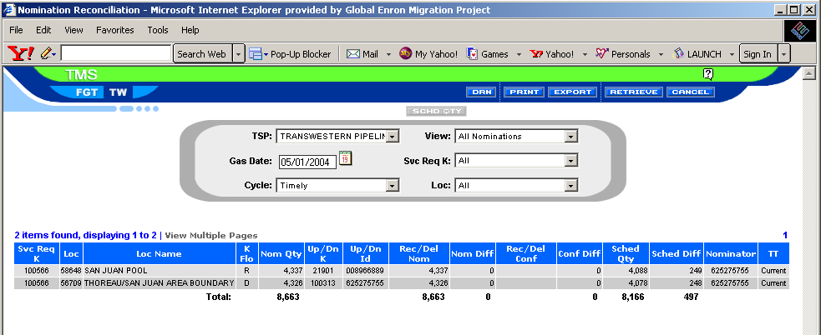
Figure 9. Nomination Reconciliation Screen
- Click the down arrow in the TSP field and select Florida Gas Transmission Company.
- Type the gas date you want to view in the Gas Date field using the mmddyy format and Tab.
- Click the down arrow in the Cycle field and select the cycle process that you want to view.
If you make no selection, the system defaults to the current cycle when you retrieve.
- Click the down arrow in the View field and select All, Nom/Conf. Exceptions, or Schedule Exceptions.
- All Nominations shows all items, both matched and unmatched, for all nominations belonging to your legal entity.
- Nom/Conf Exceptions shows the difference between the quantity you have nominated and the quantity the operator has confirmed.
- Schedule Exceptions shows the line items that have differences between nominated quantities and scheduled quantities at both physical and logical locations.
This scheduled quantity is only available after the scheduling process is complete.
- Up Down Nom Exception shows the differences between the quantity you have nominated and the quantity the upstream or downstream party has nominated at logical points. (FGT only)
- Click Retrieve after making your report selection.
The Nomination Reconciliation screen populates with all related data for the date and report selection type you selected.
To further filter this data, follow the steps shown below.
- Click the down arrow in the Svc Req K field to make a selection to filter the data to a specific contract. The default is to view all contracts.
- Click the down arrow in the Location (Loc) field to make a selection to filter the data to a specific location. The default is to view all locations.
NOTE: For FGT, nominations that were not fulfilled in a nomination cycle will be re-evaluated during the subsequent nomination cycle. Only the party that caused the mismatch must re-nominate in the next cycle. A service requester not wanting Timely or Intraday nominations to be included in the batch process must submit a change to original nomination.

Nomination Reconciliation Screen Field Help
Field Name | Definition
TSP (Transportation Service Provider) | Transportation Service Provider. Name of the pipeline: Florida Gas Transmission Company.
Gas Date | The gas date you want to view.
Cycle | The nomination cycle associated with the nomination time stamp that is generated at the time of save.
View | A filter for viewing nominations.  - All Nominations⎯Displays all items, both matched and unmatched, for all nominations belonging to your legal entity.  - Nom/Conf Exceptions⎯Shows the difference between the quantity you have nominated and the quantity the operator has confirmed.  - Sched Exceptions⎯Shows the line items that have differences between nominated quantities and scheduled quantities at both physical and logical locations.  This scheduled quantity is only available after the scheduling process is complete.  - Updown Nom Exception – Shows the differences between the quantity nominated at pools and zone points with the upstream & downstream shippers. (FGT only)
Svc Req K | A filter for viewing service requester transportation contract numbers. You can either view all available contracts or select a specific contract.
Loc | A filter for viewing the location where the quantity will be scheduled. You can either view all available locations or select a specific location.
Loc Name | Name of the location.
Nom Qty | Nomination Quantity. The quantity of gas nominated.
K Flo | Shows whether the gas flow at the location is a receipt or a delivery.
Up/Dn K | The upstream or downstream contract number.
Up/Down Id | The DUNS number of the party that is either receiving (up) or delivering (down) the gas.
Rec/Del Nom | The gas quantity nominated by the corresponding service requester at logical locations, such as pooling points and title transfer points.
Nom Diff | The difference between the upstream and downstream shippers’ gas nominated at pool and zone points.
Rec/Del Conf | The quantity confirmed by operators at physical locations.
Conf Diff | Confirmation Difference. The amount of gas the operator actually confirms as opposed to what the service requester actually nominated.
Sched Qty | The quantity of gas scheduled by the pipeline after balancing, allocation, and confirmation.
Sched Diff | The amount of gas actually scheduled by the pipeline as opposed to what the service requester actually nominated.
Nominator | The DUNS number assigned to the service requester nominating gas on the pipeline.
TT | Identifies the transaction type of the nomination.

EDI Nom Quick Response View Screen
The purpose of the EDI Nom Quick Response View screen is to provide on-line capability for viewing error messages and the status of the EDI/EDM files that you sent via the Internet.
Four status codes are used.
 | AE (E) | Acknowledge with errors
 | AE (W) | Acknowledge with warnings
 | AT | Accepted
 | RD | Rejected
Following are the instructions for using EDI Nom Quick Response View screen.
- Select Nomination|EDI/EDM Quick Response on the TMS Main Menu.
The EDI Nom Quick Response View screen opens (Figure 10).
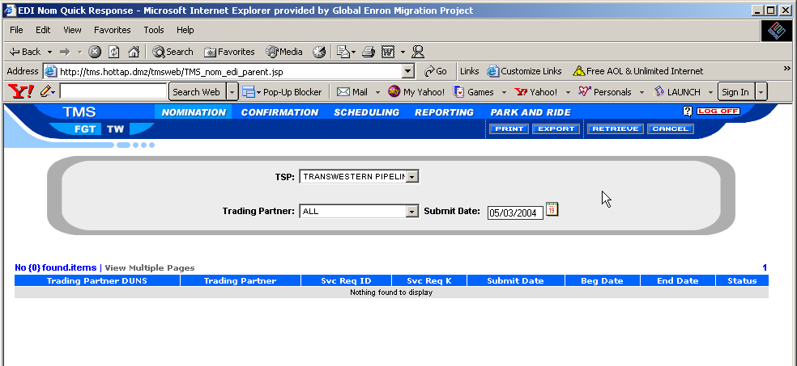
Figure 10. EDI Nom Quick Response View Screen
The TSP field defaults to the pipeline: Florida Gas Transmission Company based on your TMS security setup.
The Trading Partner field defaults to your company. The security will not allow you to view quick response information outside your legal entity.
The Submit Date field defaults to the current calendar day.
- Click in the Submit Date field and type the desired date in mmddyy format and Tab.
- Click the down arrow in the Trading Partner field and select a specific trading partner from the drop-down menu that appears. Or, default to all trading partners.
- Click Retrieve.
The menu lists the status of nominations submitted via EDI/EDM.
- Click on the quick response line for which you want to view the warning or error messages. Messages display in the area positioned below the Matrix area. The information available on this screen is systematically sent back to the service requester or agent in an EDI/EDM transmission.
6. Left-click on .
The Sort Criteria View screen appears.
You can sort on variables such as, trading partner, service requester ID, begin date,
For a detailed explanation of the sort option see Sort on Page 88.
- Click Cancel to close the EDI Nom Quick Response screen.
- Click export to download this screen data to a file to save on your PC.
- Click Print to print this screen.

EDI Nom Quick Response Screen Field Help
Field Name | Definition
Submit Date | The date the EDI/EDM nominations were submitted.
TSP (Transportation Service Provider) | Transportation Service Provider. The pipeline providing the service. For EDI transactions, this is the pipeline DUNS number.
Trading Partner DUNS | The DUNS Number of the service requester or agent trading partner submitting the EDI nominations.
Trading Partner | The name of the service requester or agent trading partner submitting the EDI nominations.
Svc Req K | Service Requester Contract number. The service requester transportation number assigned to a particular contract.
Svc Req ID | The DUNS number associated with the service requester contract.
Service Requester | Service requestor name.
Beg/End Date | The nomination beginning and ending date range.
Status | Transaction status codes.  Rejected (RD)⎯The nomination is rejected and the nomination was not loaded into the nomination system.  AE (E)⎯ There were errors in the file and if an EDI/EDM customer is a “replace” customer, the nomination did not load into the nomination system. If the EDI/EDM customer is a “change” customer, the parts of the nomination that are valid will load to the system and the part of the nomination with errors will not load to the system.  AE (W)⎯ The EDI/EDM nomination submitted has warnings, but the nomination was loaded to the system.  AT⎯ The nomination was accepted with no errors or warnings and has been loaded into the nomination system.
Tracking Number | The tracking number is created and submitted by the service requester in the EDI/EDM nomination file. The tracking number is sent back in the EDI/EDM quick response to help the service requester locate the warning(s) or error(s) in their nomination file.
Warning/Error Code | This code is the EDI/EDM warning or error code. It is generated as a result of TMS processing the service requester or agent submitted EDI/EDM nomination file.
Warning/Error Message | The warning/error message is the text definition of the EDI/EDM warning or error code.

Scheduling
Scheduling is the process TMS uses to determine the amount of gas to flow through the pipeline on a particular gas date. This scheduled amount of gas is based on nominations submitted by service requesters. Service requesters (the receipt and delivery links in the gas flow chain) may nominate conflicting gas quantities; for example, a service requester may nominate to deliver more gas than another service requester has nominated to receive from him. These discrepancies are rectified during the Scheduling process, which the pipeline uses to determine how much gas to flow from one specified location to another and how much transportation each service requester will be charged with on that Gas date. Scheduling is comprised of three major steps: Balancing, Allocation, and Confirmation. The amount of gas scheduled may differ from the nomination amount due to any of these three steps.
This section details the screens that are available for viewing scheduled information for contracts.
- Scheduled Quantities by Cycle(Page 39)
- Scheduled Quantity by Contract (Page 45)
- Scheduled Quantity by Contract and Location (Page 49)
- Scheduled Quantity by Contract, Location, and UpDown Contract (Page 52)
- Scheduled Quantity by Contract Path (Page 53)
- Batch Schedule Status (Page 54)

Scheduled Quantities
The purpose of the Scheduled Quantities By Cycle screen is to view scheduled quantities for a gas day.
- Select Scheduling|Scheduled Quantities from the TMS Main Menu.
The Scheduled Quantities screen appears and is overlaid by the Open Scheduled Quantities screen (Figure 11). You will gain access to the Scheduled Quantities screen via the Open Scheduled Quantities screen.
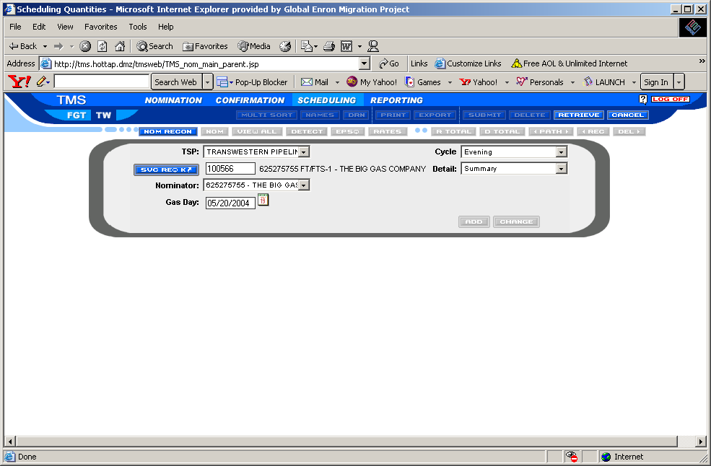
Figure 11. Open Scheduled Quantities Screen
- Click the down arrow in the TSP field on the Open Scheduled Quantities screen and select Florida Gas Transmission Company (Figure 11).
- Tab to the Svc Req K field and type the appropriate contract number, or
Right-mouse-click in the Svc Req K field to invoke the contract search function. See the Search Facility Option section on Page 81 for instructions on performing a search.
- Press the Tab key.
The Nominator field populates with related data. For FGT click on the nominator field and select the correct nominator designee.
- Type the gas date in the Gas Date field and Tab. Click the backward or forward arrow to change gas date to previous or next gas day.
- Click or press the Enter key.
The Scheduled Quantities screen populates with the scheduled quantities for the selected gas date, along with the NAESB reduction reason (RR) codes for all nominations that have been scheduled down by the pipeline (Figure 12).
See the System Tool Bar Icons section on Page 78 for a detailed description of each of the icons on the menu bar.
NOTE: Scheduled quantities are not final until the end of the gas day.
Click on the green “open new” box to open a new contract or new gas date under your current user ID Logon. This will allow you to open up to three separate scheduled quantities screens at one time.
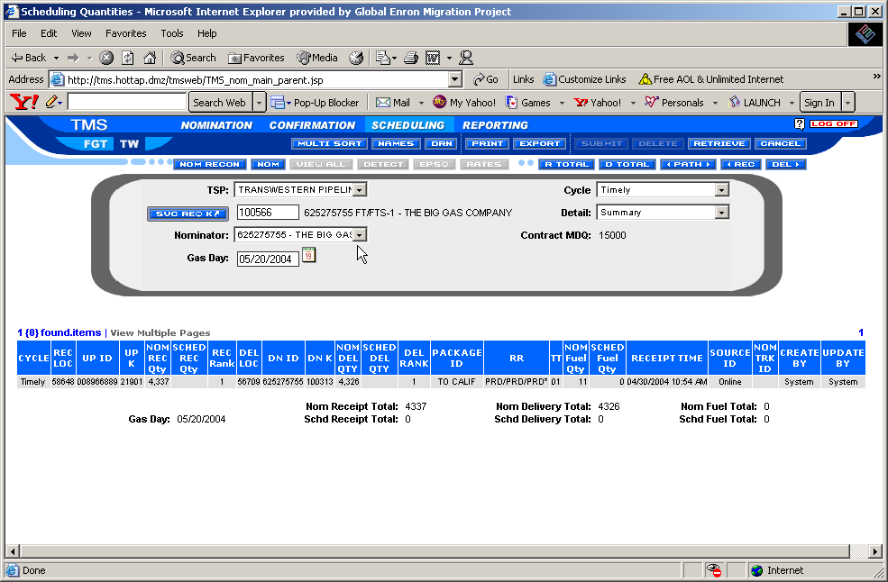
Figure 12. Scheduled Quantities Screen
If you want to investigate the reason why a path was cut, you can use the Path Detective tool. You can access the Path Detective tool from the Scheduled Quantities screen.

Path Detective
The Purpose of the Path Detective tool is to assist service requesters in reviewing scheduled quantity cuts. An asterisk in the Reduction Reason column on the Scheduled Quantities screen means that a path has had multiple cuts. The Path Detective provides a breakdown of quantities cut, along with the associated reason codes and the upstream or downstream direction in which the cut originated. The Path Detective is available for all cycles. Follow the instructions shown below to use the Path Detective.
- Open the Scheduled Quantities screen as explained on Page 49 (Steps 1 through 6).
- Highlight a path that has been cut by clicking on it (Figure 13).
A reduction code appears under the Reduction Reason column identifying all paths that have been cut.
NOTE: An * identifies that the path has multiple codes for the reduction reason.
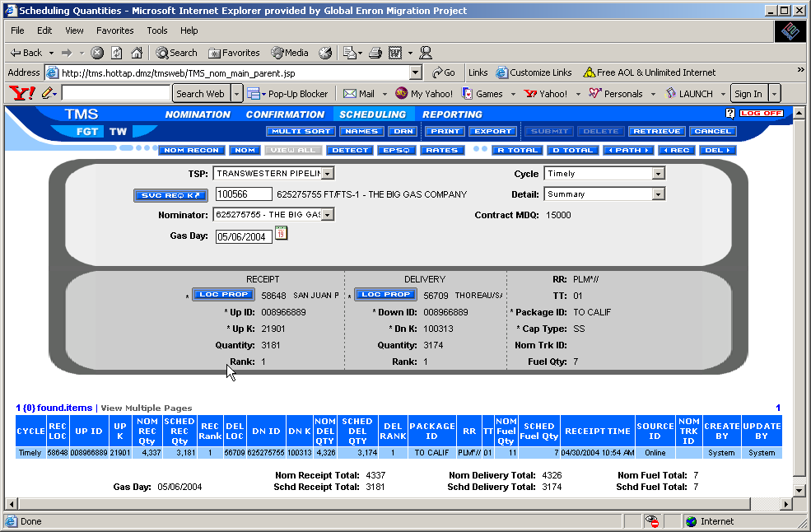
Figure 13. Scheduled Quantities Screen⎯Highlight a Path
- Click Detect on the Scheduled Quantity screen, or
Right-mouse-click on the highlighted path and select Path Detective from the pop-up menu that appears.
The Path Detective-Quantity Cuts screen appears (Figure 14). It displays all cuts associated with the contract and path you selected on the Scheduled Quantities screen.
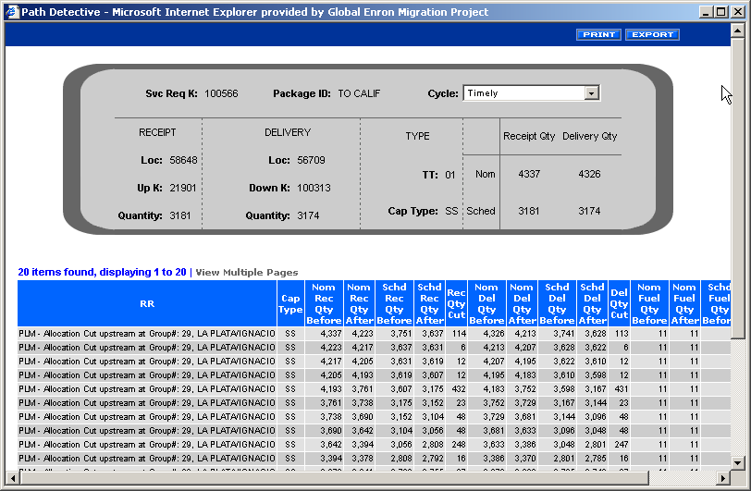
Figure 14. Path Detective⎯Quantity Cuts Screen

Scheduled Quantities Screen Field Help
Field Name | Definition
Cap Type  (Capacity Type) | Identifies the capacity type for the nomination. The capacity types only appear in the Scheduled Maintenance screen. The valid capacity types for firm contracts follow:  - PP—Primary to Primary  - PS—Primary to Secondary  - SP—Secondary to Primary  - SS—Secondary to Secondary
Cycle | The scheduling cycle associated with the nomination. It is system generated at the time of save. The valid cycles follow:  - Timely  - Evening  - Intraday 1  - Intraday 2  - Final AM
Dn ID | The downstream contract party’s DUNS #. It is populated automatically when a TMS contract number is entered in the Delivery Contract field. The system will validate that the DUNS number is a nine-digit numeric.
Nom Fuel Qty | The amount of fuel calculated for the path.
Gas Day | The date the gas is scheduled to flow.
Nom Trk ID  (Tracking Number) | The number used to track the nomination line item to the quick response and scheduled quantities. Applies only to nominations sent via EDI/EDM. The nomination originator creates the tracking number.
Nominator | FGT ONLY⎯The DUNS number assigned to the service requester nominating gas on the pipeline.
Package ID | An optional field that may be used to describe the nomination at a lower level.
Rec Loc  Del Loc  (Location) | Represents the receipt/delivery location for your nomination on your contract.  Click the Location Date field using the right mouse button to access a location wizard (search function), or use Lookup Views from the menu bar.  A list of valid delivery locations for that contract along with other location detail information will display.
Nom Rec Qty  Nom Del Qty  (Quantity) | The amount of gas that the service requester will nominated from or deliver to the market.
Rec Rank  Del Rank  (Rank) | The receipt/delivery priority (1 to 999) assigned by the service requester to identify the order of which gas should be scheduled by the pipeline. The higher the rank number, the greater the risk of being cut. For example, gas assigned a rank of 99 will be cut before gas assigned a rank of 1. If no rank is entered, the system will default to 500.
Receipt Time | The nomination timestamp for transactions. It is system generated at the time of input and save.
RR  (Reduction Reason) | Reduction Reason. Identifies the types of cuts made by the pipeline when scheduling the contract. Each type of cut is assigned a specific code.
Source ID | The way in which the nominated transactions were entered (in other words, on-line or EDI/EDM). The source ID is system generated.
TT  (Transaction Type) | Identifies the transaction type of the nomination.
Up ID | The upstream contract party’s Duns #. It is populated automatically when a TMS contract number is entered in the Receipt Contract field. The system will validate that the DUNS number is a nine-digit numeric.
Up K  Dn K  (Contract) | Identifies the upstream/downstream contract at the respective receipt/delivery location. The TMS contract number is required for all Park N Ride, and pool locations. The system will validate the TMS contract entered and display the correct DUNS number in the ID Code field after you leave this field.  A Non-TMS Contract number is required at all physical locations. This field can be an alphanumeric field. The DUNS number must be manually entered in the ID Code field when entering a Non-TMS contract.
Sched Rec Qty  Sched Del Qty | The amount of gas that the service requester will receive from or deliver to the market.
Sched Fuel Qty | The amount of fuel scheduled for the path.
Created By | The user ID tied to the nominated transactions on the nomination. On the scheduled quantity by cycle screen, the user ID is identified as system generated.
Updated By | The user ID tied to the nomination transactions that updated the original nomination. On the scheduled quantity by cycle screen, the user ID is identified as system generated.

Scheduled Quantity by Contract
The purpose of the Scheduled Quantity by Contract screen is to view all scheduled paths for a particular contract by date range.
- Select Scheduling|Schedule Quantities by…|by Contract on the TMS Main Menu.
The Scheduled Quantity By Contract screen appears (Figure 15).
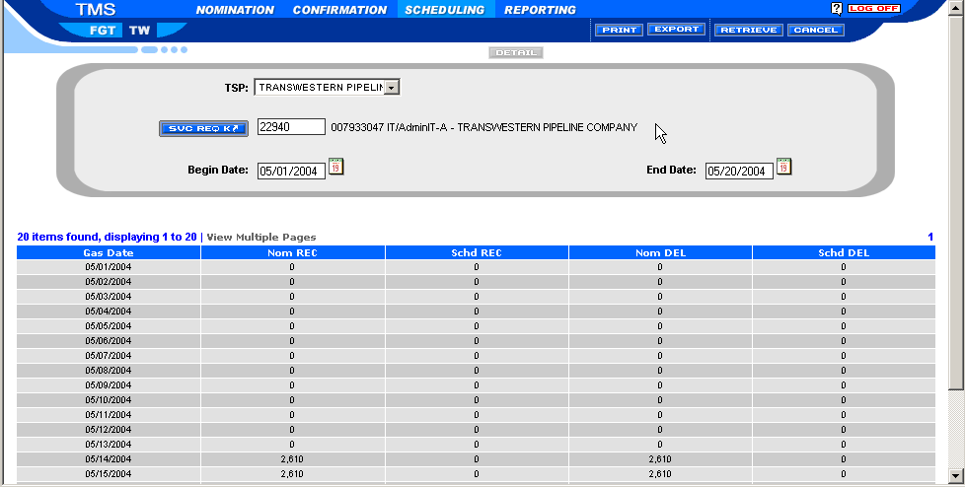
Figure 15. Scheduled Quantity By Contract Screen
- Click the down arrow in the TSP field and select Florida Gas Transmission Company.
- Tab to the Svc Req K field and type the appropriate contract number, or
click in the Svc Req K field to invoke the contract search function. See the Search Facility Option section on Page 81 for instructions on performing a search.
- Type the begin and end dates in the Beg/End fields and Tab.
- Click Retrieve.
The Scheduled Quantity By Contract screen populates with the nominated Receipt and Delivery contract totals by day and the Schedule Receipt and Delivery contract totals by day.
- To view contract quantity detail data for a specified gas day, highlight the desired gas day on the Scheduled Quantity By Contract screen.
- Click Detail.
The Contract Quantity Detail List screen opens and is populated with the nominated and scheduled quantity totals by location listed in ascending order (Figure 16).
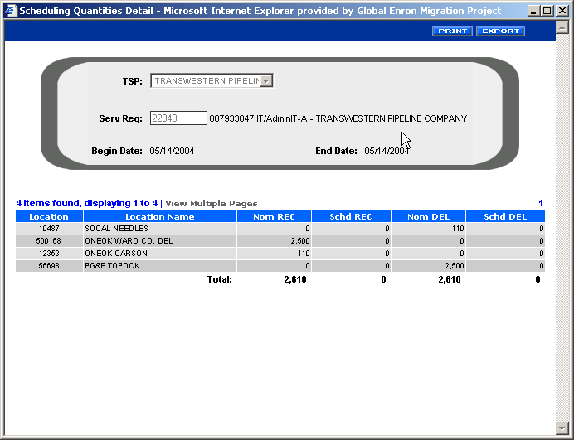
Figure 16. Contract Quantity Detail List Screen
- Click Print to print the screen.
- Click Export to export screen data to a Tab delimited text file.
- Click the arrows in the column headings to sort or change the order of the columns in the screen.
- Click Cancel to exit this screen.
You are returned to the Scheduled by Quantities Contract screen.

Scheduled Quantity By Contract Screen Field Help
Field Name | Definition
TSP (Transportation Service Provider) | Name of the pipeline: Florida Gas Transmission Company.
Svc Req K | The service requester transportation number assigned to a particular contract.
Gas Date | The start date of the nomination.
Nom Delivery | The quantity nominated at a delivery location.
Nom Receipt | The quantity nominated at a receipt location.
Sched Delivery | The quantity scheduled at a delivery location.
Sched Receipt | The quantity scheduled at a receipt location.
Beg/End | The nomination beginning and ending date range.

Contract Quantity Detail Screen Field Help
Field Name | Definition
TSP (Transportation Service Provider) | Name of the pipeline: Florida Gas Transmission Company.
Svc Req K | The service requester transportation number assigned to a particular contract.
Begin/End | The nomination beginning and ending date range.
Location | The location where the quantity will be scheduled.
Location Name | Name of the location.
Nom Receipt | The quantity nominated at a receipt location.
Sched Receipt | The quantity scheduled at a receipt location.
Nom Delivery | The quantity nominated at a delivery location.
Sched Delivery | The quantity scheduled at a delivery location.
Totals | The total amount of gas nominated and scheduled at the receipt and delivery locations for the date range entered.

Scheduled Quantities by Contract and Location
- Select Scheduling|Scheduled Quantities by|by Contract and Location.
The Scheduled Quantities by Contract/Location screen appears (Figure 17).
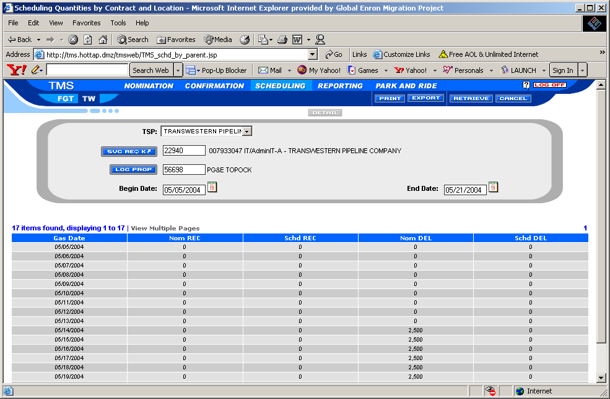
Figure 17. Scheduled Quantities by Contract/Location Screen
- Click the down arrow in the TSP field and select Florida Gas Transmission Company.
- Tab to the Svc Req K field and type the appropriate transportation contract number, or click in the Svc Req K field to invoke the contract search function. See the Search Facility Option section on Page 81 for instructions on how to perform a search.
- Tab to the Loc Prop field and type the appropriate location for the contract then Tab.
- Type the begin and end dates in the Beg/End fields then Tab.
- Click Retrieve.
The Scheduled Quantities by Contract/Location screen populates with the nominated and scheduled totals by day.
- Click Print from the menu bar to print the screen.
- Click Export or select to export the data into a file.
You can then save the data to your PC.
- Click Multi Sort to sort or change the order of the columns in the screen.
You can change the sort order of individual columns by clicking the arrow in the column heading box.
- Click Cancel to exit this screen.
Ascending Order | Descending Order
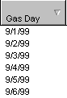 | 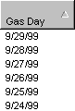

Scheduled Quantities by Contract and Location Screen Field Help
Field Name | Definition
TSP (Transportation Service Provider) | Name of the pipeline: Florida Gas Transmission Company.
Svc Req K | The service requester transportation number assigned to a particular contract.
Loc Prop | Location Proprietary Code or DRN number assigned by the pipeline for a specific location where the quantity will be scheduled.
Begin/End Date | The nomination beginning and ending date range.
Gas Date | The start date of the nomination.
Nom Receipt | The quantity nominated at a receipt location.
Sched Receipt | The quantity scheduled at a receipt location.
Nom Delivery | The quantity nominated at a delivery location.
Sched Delivery | The quantity scheduled at a delivery location.
Totals | The total amount of gas nominated and scheduled at the receipt and delivery locations for the date range entered.

Scheduled Quantities by Contract, By Location and Up/Down Contract
- Select scheduling / scheduled quantities by contract/location and up/down contract
Screen appears (figure 19)

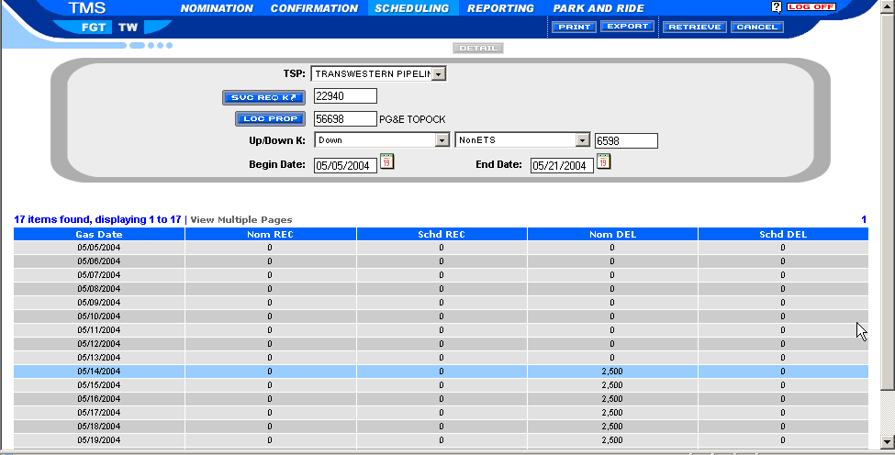
Figure 19. Scheduled Quantities by Contract / Location Up / down contract Screen
- Click the down arrow in the TSP field and select Florida Gas Transmission company.
- Tab the Svc Req K field and type the appropriate transportation contract number then Tab, or click in the Svc Req K field to invoke the contract search function. See the search option section on page 71 for instructions.
- Tab to the Loc. Prop field and type the appropriate location for contract then Tab.
- Select the up/down stream contract reference for receipt or delivery location selected, and then click on non ETS or ETS Contract reference for pooling points or physical points. Enter the correct upstream / downstream contract number.
- Enter a begin date and end date range for your search criteria and Tab.
- Click Retrieve. The scheduled quantity details will populate.
- Click print from the menu to print the screen.
- Click export to export the data into a file on your PC.
- Click cancel to exit this screen.
Scheduled Quantity by Contract Path
The purpose of the scheduled quantity by Contract Path Screen is to view scheduled paths for a particular contract for a date range. This new view will be summarized to a path level and display all nominated and scheduled receipt and delivery paths for a range of dates.
- Select Scheduling|Scheduling Quantities by…|by Contract Path on the TMS main menu. The scheduling quantities by contract path appears (figure 20)
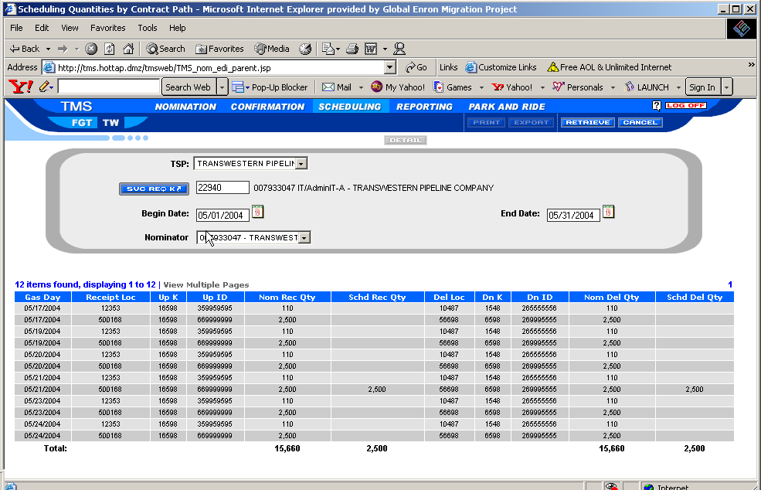
Figure 20 . Scheduling Quantities by Contract Path
- Click the down arrow in the TSP field and select Florida Gas Transmission Company.
- Tab to the Svc. Req. K field to invoke the contract search function.
- Type the begin date and end date or use the calendar to select the begin and end dates and Tab.
- If applicable, select from the drop down list the nominator duns number for agent / designee roles.
- Click Retrieve. The Scheduling Quantities by Contract Path view populates.
- Click Print to print the screen.
- Click Export to export screen data to a file to save on your plc.
- Click Cancel to clear this contract request from this screen.

Batch Schedule Status
The purpose of the Batch Schedule Status screen is to provide the customer a view of the processing cycles for a given gas day. This screen displays three successive gas days (current, prior, and next day). The cycles identify which process is completed or currently processing. Once a cycle has completely processed, the scheduled quantities are available to view through the various scheduled quantities screens, such as Scheduled Quantities by Contract and Scheduled Quantities by Contract by Point.
- Select Scheduling|Batch Schedule Status from the TMS Main Menu.
The Batch Schedule Status screen opens (Figure21.)
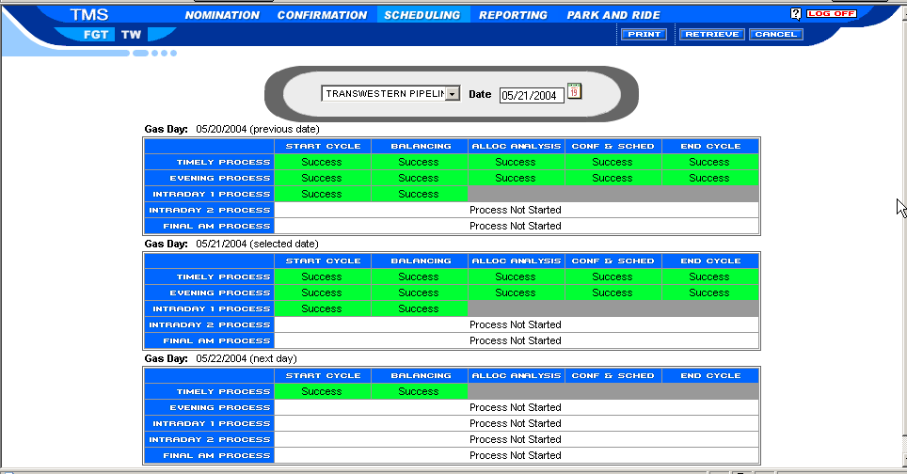
Figure21. Batch Schedule Status Screen
- Click the down arrow in the TSP field on the Batch Schedule Status screen and select Florida Gas Transmission Company.
- Type the gas date in the Date field and Tab.
- Click Retrieve.
The data will be displayed when the balancing and/or the confirmation and scheduling processes are completed for the three daily cycles (previous, selected and next day).
- Click Cancel to exit this screen.
- Click Print to print this screen.

Reporting
The reporting feature allows you to view on-line or print hard copies of your service requester Scheduled Quantities report.
You can view four reports: TMS Scheduled Quantities Report , TMS PNR Report, TMS Service Request Report, and for FGT only, the FGT Daily Balance Report. The instructions for viewing these reports are shown below.

Scheduled Quantities Reports
The Scheduled Quantities Report displays your nominated and scheduled quantities for a particular contract and gas day. This report also displays month-to-date totals for your contract.
- Select Reporting|Scheduled Quantities Report from the Main Menu.
The Scheduled Quantities Reports screen appears (22). You will select different variables on this screen to filter down to the specific data you want to view.
NOTE: Scheduled Quantity For Operator reports are only available to operators.
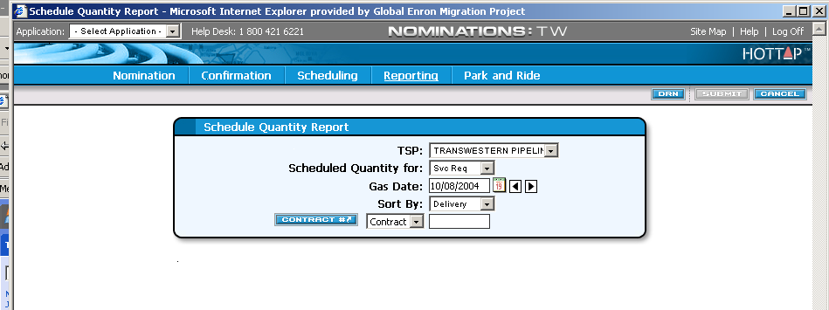
Figure 22. Scheduled Quantities Report Selection Screen⎯Service Requester View
- Click the down arrow in the TSP field and select Florida Gas Transmission Company.
- Click the down arrow on the scheduled quantity for selection field to select Svc Req. or operator.
- Type the gas day in the Gas Date field and Tab.
- Click the down arrow to select the Receipt Location or Delivery Location in the Sort By field and Tab.
- Click the down arrow to elect either Contract or ID and type the appropriate corresponding number. The ID number is your Legal Entity number. Tab to the K# or LE# and click to invoke the search function.
- Click Submit on the title bar to view the report.
The Report screen appears (Figure 23).
It displays the nominated and scheduled quantity information for the receipt and delivery locations, along with the month-to-date quantities.
- Click the scroll bar to scroll through the pages of contracts and location detail.
- Click on the title bar to print the report. The print option box opens.
- Click Properties on the print options and select Landscape orientation then click ok to save Landscape. Click ok to print report.
- Click the button in the top right corner of the screen.
You are returned to the Scheduled Quantities Reports screen.
- Click in the upper left corner of the page on the “click here to save the following report to Excel” data field to export the report to Excel.
- Click on the Scheduled Quantities Reports screen to clear the report request.

NOTE: For FGT, the POI Icon will allow you to retrieve the report data by POI number vs. Drn Number.

NOTE: The Scheduled Quantities Reports screen will be available to view and print throughout the day. For Timely Scheduled Quantities, this screen will be available to view and print on-line at 4:30 p.m. CCT one day prior to gas flow and after each Intraday cycle. Please keep in mind that the quantity shown is based on the scheduled quantities in place at the time you retrieve the report and is subject to change as each batch process is completed or as Intraday nominations are scheduled.

Service Requester Report
The service requester report displays nominated and scheduled quantities for a particular gas day cycle and contract or for a range of gas days and contract.
- Select Reporting Service Requester report from the main menu. The service requester report screen appears ( figure 24) you will select different variables on this screen to filter down to the specific data you want to view.

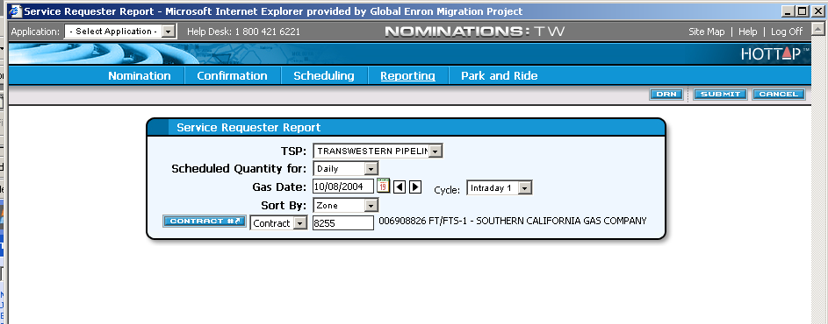
Figure 24. Service Requester Report view
- Click the down arrow in the TSP field and select Florida Gas Transmission Company.
- Click the down arrow in the scheduled quantity for field and select daily or date range.
- Type the gas day in the date field and Tab.
- Click the down arrow in the sort by field and select the sort option.
- Click the down arrow to select either contract or ID and type the appropriate corresponding number. The ID number is your Legal Entity (Dun’s) number.
- Tab to the K# or LE# field and click to invoke the contract search function.
- Click submit on the title bar to view the report. The report screen appears (figure 25). It displays the nominated and scheduled quantity information for the receipt and delivery locations.
- Click the scroll bar to scroll through the pages of the report.

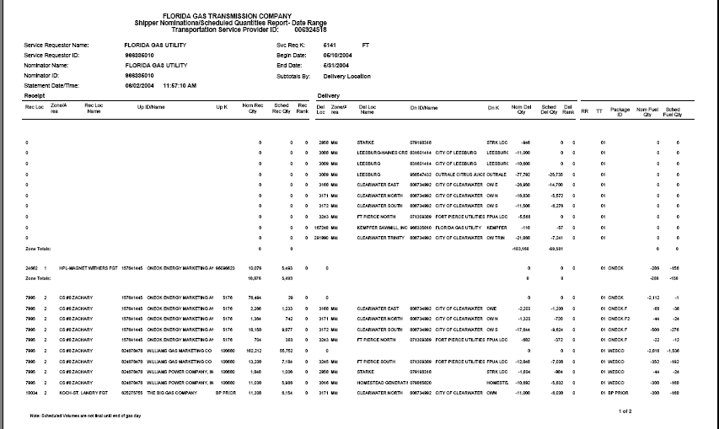
Figure 25. Service Requester Report
- Click Printer Icon on the title bar to print the report. The print option box opens.
- Click Properties on the print option and select Landscape Orientation. Then click Advance button on the print option box to select paper size to legal in the drop down list and click Ok twice to activate the printing function to legal size report.
- Click the button in the top right corner of the screen. You are returned to the service requester report.
- Click in the upper left corner of the page on the “click here to save the following report to Excel” data field to export the report to Excel file on your PC.
- Click Cancel on the service requester report screen to clear the report request.
NOTE: The service requester reports screens will be available to view and print after each cycle and throughout the day. Please keep in mind that the quantity shown is based on the scheduled quantities in place at the time you retrieve the report and is subject to change as each batch process is completed.
NOTE: For FGT, the POI Icon will allow you to retrieve the report data by POI number vs. DRN number vs. DRN number.

FGT Daily Balance Report (FGT Market Area Shippers & Operator Only)

The FGT daily balance report displays nominated, scheduled, estimated and actual volumes for shippers & operators in the FGT market area.
- Select reporting| FGT daily balance report from the main menu. The FGT daily balance reports screen appears. (Figure 26) you will select different variables on this screen to filter down to the specific data you want to view.
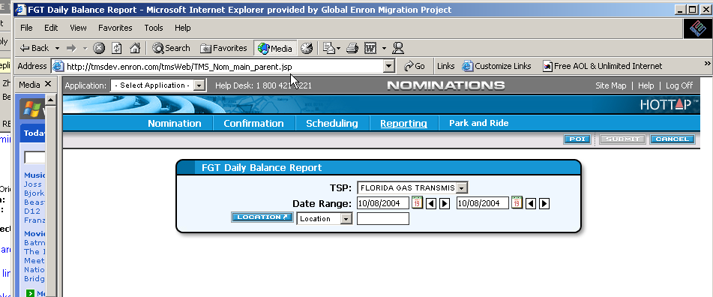
Figure 26. FGT daily balance report view

- Click on the TSP field and select Florida Gas Transmission Company.
- Type the gas day in the date range field or select the calendar to activate the date range and Tab. The next and previous arrows can also be used to select date.
- Click the down arrow to select the location, all locations or group and type the appropriate corresponding number. When you select all locations, the system will default to the points tied to your logon ID.
- Tab to and click in the location or group field to invoke the search function to lookup a particular point or group.
- Click Submit on the title bar to view the report. The report screen appears (figure 27). It displays the shipper/operator points in the market area with nominated, scheduled and estimated or actual volumes that populate from points with daily measurement information as well as a daily balance.

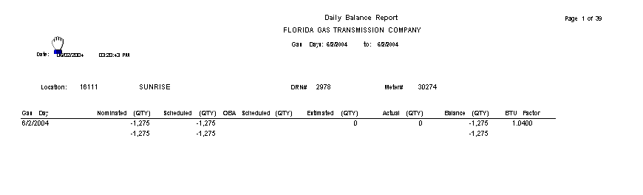
Figure 27. FGT daily balance report
- Click the scroll bar to scroll through the pages of the report.
- Click printer icon on the title bar to print the report. The printer box option opens.
- Click print to activate the printing function.
- Click the button in the top right corner of the screen. You are returned to the FGT daily balance report.
- Click the upper left corner of the page on the “click here to save the following report to Excel” data field to export the report to Excel file on your PC.
- Click Cancel on the FGT Daily Balance report screen to clear the report request.

NOTE: Please keep in mind that the nominated and scheduled volumes shown is based on the quantities in place at the time you retrieve the report and are subject to change as each batch process cycle is completed. Actual volumes are on a 2 to 3 day lag time.

TMS Generic Screen Functions
Following are detailed instructions for using the basic screen functions that are generic to the TMS program. The other sections of this manual reference these instructions.
- System Tool Bar Icons (Page 78)
- Search Facility Option (Page 81)
- Sort (Page 88)
- Print (Page 90)
- Export (Page 91)
Each of the above-mentioned functions is explained in detail below.

System Tool Bar Icons
The following tool bar icons are used generically throughout the TMS program.
Icon | Notes
Delete | Deletes selected information at a line item level.  Only paths that have not been scheduled can be deleted.
Del | Identifies only the delivery side of the data fields. Use this for delivery makeup only transactions on a contract, such as pooling, storage, makeup, or P-N-R. When you click Delivery, the system removes the receipt input data fields and defaults the Transaction Type to code 04, which is imbalance payback from the pipe.
Dtotal | Delivery Total. Sums all applied delivery location totals in POI number order. Displays location number, location name, and total POI quantity. For FGT DRNs will be displayed.
EPSQ | Elapsed Pro-rata Scheduled Quantity (EPSQ). Displays the EPSQ calculation for the highlighted path, thus allowing you to see the reason why your nominated quantity is less than the actual scheduled quantity.
Exit | Closes the active screen and returns you to the main menu.
Export | Exports data on the active screen to a tab delimited file. You can then customize the data into your own file as needed.
Open New | Opens the Contract screen where you can enter and select the company, contract number, and gas day you want to retrieve. The Contract screen also provides a copy function that allows you to copy the entire nomination from one gas date to a new gas date range.
Path | Identifies the type of transaction that you are going to enter in the data fields. For transportation contracts, the system defaults to a path transaction that requires both receipt and delivery information to be entered in the data field.
Detect | Enables service requesters to view scheduled quantity cuts made by the pipeline for the each cycle.
Print | Prints the entire nomination detail for the contract that you have open regardless if all paths have been saved.
Rates | Commodity Path rate information can be viewed for the contract nomination path detail line that you have highlighted in the data display area. This rate is based on the information available at the time of nomination and is subject to change. This feature is not available for FGT at this time.
Rec | Identifies only the receipt side of the data fields. Use this for receipt makeup only transactions on a contract, such as pooling, storage, makeup, or P-N-R. When you select the Rcpt Icon, the system removes the delivery input data fields and defaults the Transaction Type to code 03 which is imbalance payback to the pipe.
Retrieve | Retrieves pre-existing data for the gas day selected. Re-retrieves the contract you already have open.
Rtotal | Receipt Total. Sums all applied receipt location totals in POI number order for the gas day of the path highlighted in the Data Display area. Displays location number, location name, and total POI quantity. For FGT, DRNs will be displayed.
Submit | Saves all current updates to TMS database if all validation criteria are met. If an error message appears changes will not be saved. All error messages must be adjusted and corrected before the nomination can be saved.
Names | Identifies the receipt or delivery point name.
Multi-Sort | Sorts all applied data fields available in the Selection View screen (ascending or descending order) based on the selection criteria the user selects.

Search Facility Option
Four basic search options are available to you in the TMS system:
- Search (81)
- Location Search (81)
- Receipt|Delivery Locations Valid for Contract (86)
- Location Detail Information (87)
The type of search you can perform depends upon the field from which you invoke the search option. For example the Svc Req K field invokes the Search option. The *Loc Prop field invokes the Location Search, Location Detail Information, and Receipt Locations Valid for Contract options.
The search screens may vary slightly across the pipelines; thus, this manual shows screen shots for each pipeline.
NOTE: Once you have performed a search and have retrieved a list of data, you can sort that data in various ways. See the Sort section beginning on Page 88 for detailed instructions.

Search and Location Search Options
The Search and Location Search menu options work similarly; thus, both operations are explained in this section.
- Click in either a location type field or a contract type field , on the screen you are currently viewing.
The search menu appears.
NOTE: On some screens, you can click a location type ,
or a contract type , button to invoke the search engine.
- Select Location Search or Search from the respective menu.
The related Search Facility screen appears (Error: Reference source not found through Error: Reference source not found).
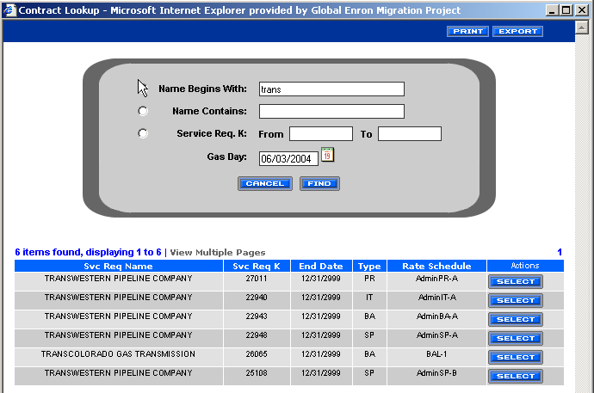
Figure 31. Contract Search Screen⎯

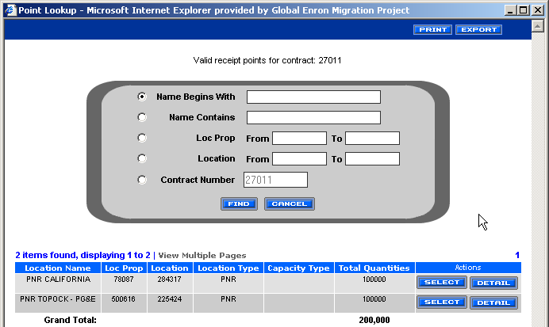
Figure 32. location Search Screen⎯

- Click the radio button to the left of the desired search method so that it turns black.
Follow the individualized instructions below for each of the search scenarios.

Name Begins With
Name Begins With searches on company name.
- Type the first letter or the first few letters that you know of the contract name in the Name Begins With field.
- Click Find.
The display area populates with all contracts available to your logon ID beginning with the letter(s) you typed.
- Click Select on the contract in the scroll list that you want to retrieve.
You are returned to the screen from where you initiated the search. Its fields are now populated with related data.
- You are now ready to perform operations on the contract you invoked.

Name Contains
Name Contains searches on company name.
- Type any portion of the contract name that you know in the Name Contains field.
- Click Find.
The display area populates with all contracts available to your logon ID that contains the letter(s) you typed.
- Click Select Box on the contract in the scroll list that you want to retrieve.
You are returned to the screen from where you initiated the search. Its fields are now populated with related data.
- You are now ready to perform operations on the contract you invoked.

Svc Req K
Svc Req K searches on contract number.
- Type a range of contract numbers (N to N) on which you want to perform a search in the Number field.
- Click Find.
The display area populates with all contracts available to your logon ID within the range of contract numbers you typed.
- Click Select Box on the contract in the scroll list that you want to retrieve.
You are returned to the screen from where you initiated the search. Its fields are now populated with related data.
- You are now ready to perform operations on the contract you invoked.

Loc Prop
Loc Prop searches on location numbers.
- Type a range of Location numbers (N to N) on which you want to perform a search in the Loc Prop field.
- Click Find.
The display area populates with all contracts available to your logon ID within the range of location numbers you typed.
- Click the Select Box on the contract in the scroll list that you want to retrieve.
You are returned to the screen from where you initiated the search. Its fields are now populated with related data.
- You are now ready to perform operations on the contract you invoked.

Location
Location searches on DRN numbers.
- Type a range of DRN numbers (N to N) on which you want to perform a search in the Location Number field.
- Click Find.
The display area populates with all contracts available to your logon ID within the range of DRN numbers you typed.
- Click the Select Box on the contract in the scroll list that you want to retrieve.
You are returned to the screen from where you initiated the search. Its fields are now populated with related data.
- You are now ready to perform operations on the contract you invoked.

Receipt/Delivery Locations Valid for Contract
The Receipt|Delivery Locations Valid for Contract search screens can only be invoked from the Nomination Maintenance or the scheduled Qty by cycle screen. It displays only those locations that are valid for the contract you have invoked when nominating operator imbalance gas. The instructions below explain how to use the Receipt|Delivery Locations Valid for Contract search screens.
- On the Nomination Maintenance screen click in either the Location field or the Loc Prop field (depending upon your pipeline view). The Receipt|Delivery Locations Valid For Contract screen appears and displays all valid locations for your contract). On the point look up search screen.
- Click Select on the desired location in the Matrix area of the screen.
The screen from which you initiated the search will populate with the selected point.

Location Detail Information Display
The Location Detail Information Display search screen can only be invoked from the Nomination Maintenance screen. It displays specific information related to the point that you entered in either the Location field or the Loc Prop field (depending upon your pipeline view).
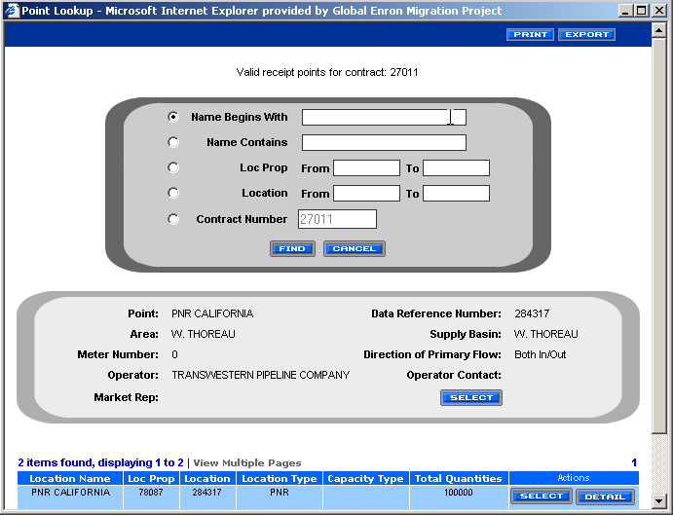
Figure 33. Loc. Detail Info. Display⎯FGT
- Click on the Location field or the Loc Prop field (depending upon your pipeline view). The point lookup screen appears with the valid receipt or delivery points for the contract.
- Click the Detail Action Box for the location you wish to view..
- Select Location Detail Information from the drop-down menu that appears.
or the Location Detail Information Display screen appears for the point selected. It displays information related to the location you selected.
- Click to close the Location Detail Information Display screen.

Sort
Sorts are performed in basically the same manner on all screens. The various sort options are explained below.

Data Sorts
- Click Multi Sort Icon. The Sort Criteria View screen appears (Figure 34).
NOTE: You can also invoke the sort option by clicking in the Matrix area of the screen.
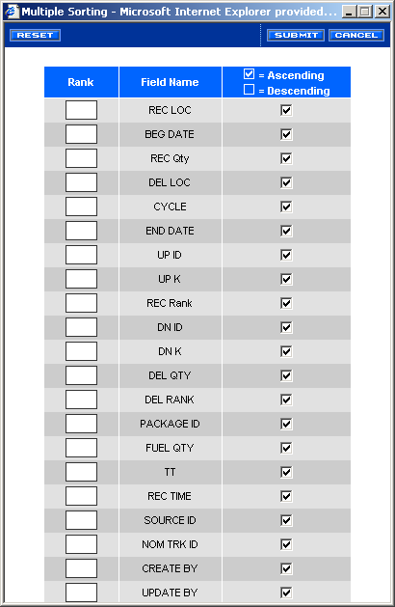
Figure 34. Sort Criteria View
- Select the order of rank in the rank column beginning with the number 1 in the first column you wish to sort. Continue with the additional field sorting by sequentially numbering the column field names you wish to sort in the rank column.
3. Click either Ascending or Descending depending on the direction that you want to sort.
- If you change your mind and do not want to sort on one of the variables you have selected, click reset to clear the sort or change the rank column to the new rank number.
- Click Submit to activate the sort function on the active screen..
- Click Cancel to close the multi Sort screen.

Column Sorts
You can perform a sort on a specific data column. The explanation follows.
- Click on a column header. For example, 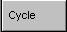. The sort option on these columns is a toggle.
- Click once and it sorts in ascending direction 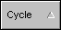.
- Click again and the system toggles to sort in the descending direction 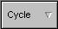.

Print
- Click Print. The print option box appears.
- Select the Printer you wish to print to.
- Click on Lay Out Option.
- Select Landscape.
- Click Advanced Option if your wish to change the paper size from letter to legal and click Ok.
- Click Print Option to print.

Export
You can export a file from any TMS screen that has the Export icon; for example, the Scheduled Quantity By Cycle screen (Figure 35).
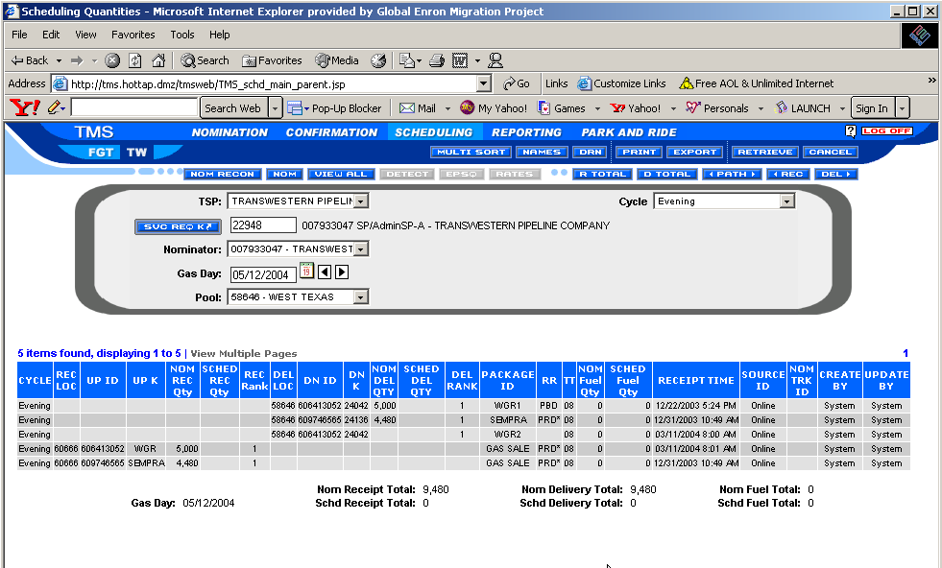
Figure 35. Scheduling Maintenance Screen - Export
- Retrieve the contract that you want to export.
- Click Export.
The Screen Data displays in a file format layout.
- Click file, save as: The name file to be exported appears (figure 36)
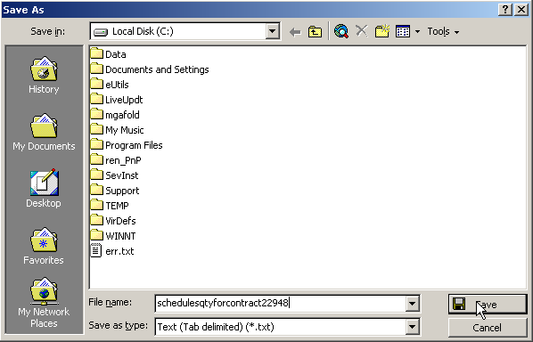
Figure 36. Name File to be Exported Screen

- Click in the File name field and change the file name if necessary and add the extension for the file type you want to use. For example, .xls for an Excel file. Select the Director file on your PC.
- The Files of type field is not active. Select the type of file.
- Click Save.
All data related to the selected contract is exported to the specified directory.
NOTE: To ensure that you have access to your exported files after disconnecting, you must download them to your local PC.

Cancel
Click Cancel to clear the screen.

